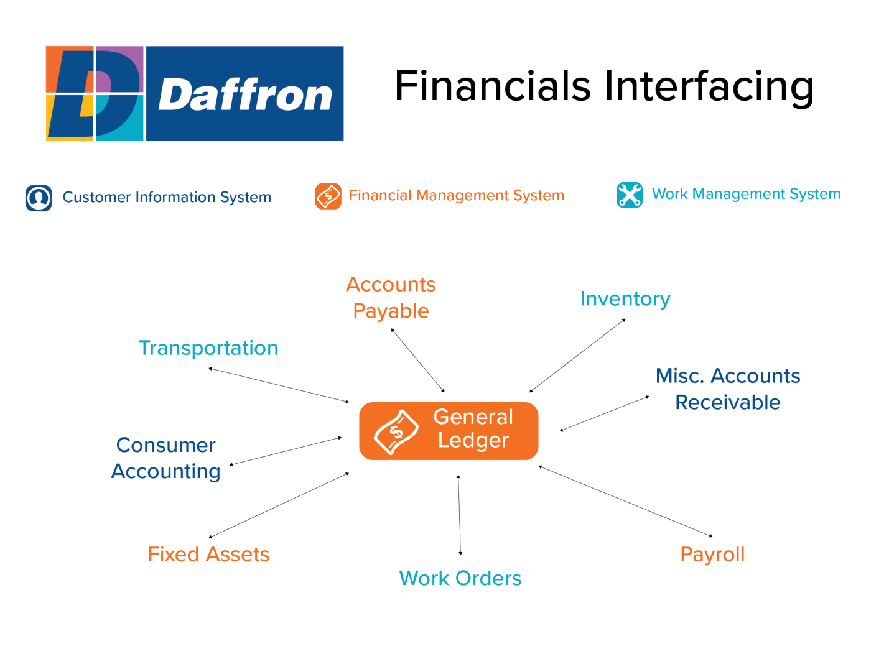
The General Ledger system has multiple interfaces within the Daffron application software.

- The General Ledger system will automatically validate any general ledger number entered into Accounts Payable; Payroll; Fixed Assets; Inventory; Work Order; Staking; Transportation, Miscellaneous Accounts Receivable, and Consumer Accounting.
- All general ledger entries made in Accounts Payable are sent to the General Ledger.
- Inventory will send all journal entries to General Ledger.
- Transportation will send all journal entries to General Ledger.
- Miscellaneous Accounts Receivable will send all journal entries to General Ledger.
- Consumer Accounting will send all journal entries to General Ledger.
- Fixed Assets will send all its journal entries to General Ledger.
- Work Orders will send all journal entries to General Ledger.
- Payroll will send all general ledger entries and statistical information that was entered into Time Entry to General Ledger.

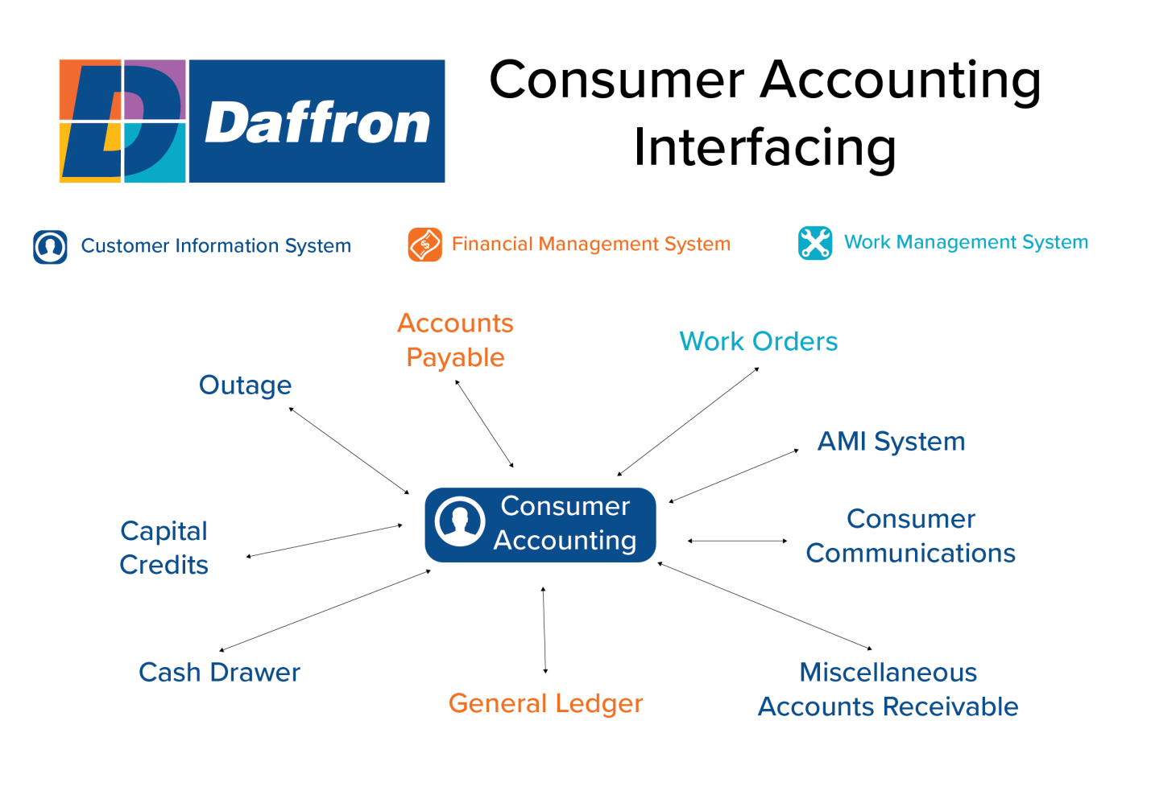
The Consumer Accounting system seamlessly interfaces with the various Daffron applications.

- Consumer Accounting will create temporary vendors and pass credit balances to Accounts Payable, as well as invoices for deposits and memberships applied. Billing Refunds can create Accounts Payable invoices.
- General Service Orders updated through Work Orders are passed directly to Consumer Accounting.
- Service Order and Work Order tracking integrates these two systems for step-by-step tracking of each job. The tracking can be established in either system. Additional integration includes creation of construction Work Orders at the time a new Construction Service Order is entered. This is accomplished by defining specific service order types as “Work Order Interfaced”.
- For cooperatives using Capital Credits, patronage information is automatically passed from Consumer Accounting to Capital Credits.
- Capital Credits creates journal entries and sends them to Consumer Accounting, which transfers those journal entries to General Ledger.
- Cash Drawer will pass all payment transactions to Consumer Accounting real time.
- Consumer Accounting will automatically validate account numbers that are entered into Cash Drawer.
- General Ledger validates general ledger numbers entered into Consumer Accounting.
- Consumer Accounting will pass all journal entries to General Ledger.
- Misc. Accounts Receivable charges can be optionally transferred to Consumer Accounting to be billed.
- Payment transactions are posted to Accounts Receivable through Consumer Accounting.
- Consumer Accounting will validate all account and location numbers entered into Outage.
- Outage has the ability to produce service orders that will be automatically sent to Consumer Accounting.
- Consumer Accounting will validate by account or location number. User-definable customer information is stored in Consumer Statistics.
- Real-time billing and payment information to customers via web. Customers can make payments, request service, report problems, etc.
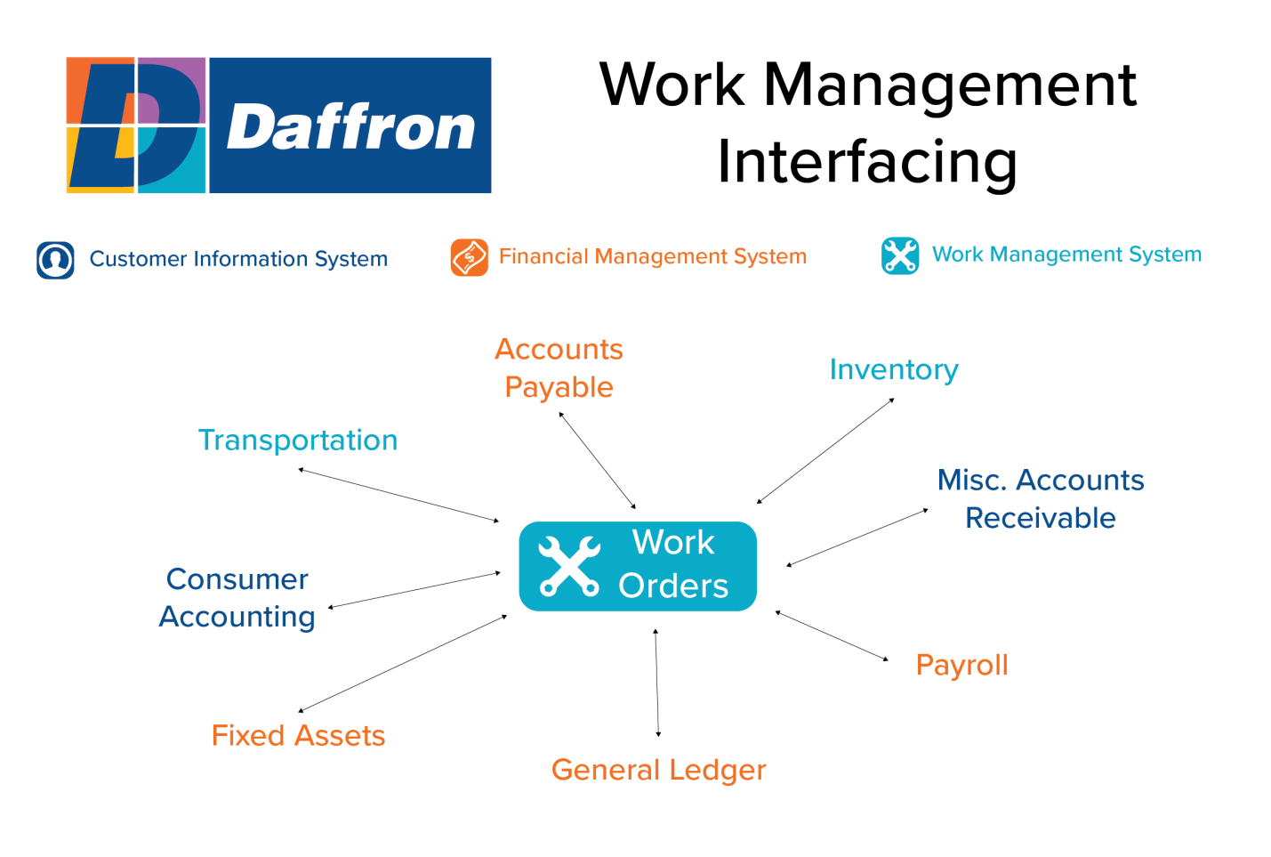
Work Orders seamlessly interfaces with multiple Daffron applications.

- Work Orders will automatically validate work order numbers entered in Accounts Payable Invoice Entry.
- Accounts Payable will send all direct charges to Work Orders at Month Close.
- Work Orders will validate any work order number entered in Inventory.
- Inventory will send material transactions to Work Orders immediately or at month close.
- Work Orders will validate any work order number that is entered in Transportation Equipment Use transactions.
- Transportation will send all vehicle costs associated with work orders to Work Orders at Month Close.
- Work Orders will validate any work order number in Inventory.
- Inventory will send all Continuing Property Record (CPR) transactions to Work Orders.
- Through the use of a function key, you are always able to enter General Service Orders in Work Orders and pass them directly to Consumer Accounting.
- There is an option to create a work order when entering a service order in Consumer Accounting.
- Work Orders will send all CPR transactions to Fixed Assets at Month Close. Fixed Assets will automatically create a fixed asset record for CPRs that have not been established within Fixed Assets.
- General Ledger will validate all general ledger account numbers entered in Work Orders and will verify that Work Orders has been closed before General Ledger is closed.
- Work Orders will send all journal entries to General Ledger.
- Work Orders will validate all work order numbers that are entered on time sheets in Payroll Time Entry.
- Payroll will pass labor charges to Work Orders. The user will decide if this exchange of information is done at Pay Period Close or at Month Close.
- Work Orders will send detail data to Misc. Accounts Receivable for any billable Work Orders.
- Work Orders will validate all work order numbers that are entered in Misc. Accounts Receivable.

